Active Network Meet Entry
Step 1: You will receive an email inviting you to sign up for an upcoming meet
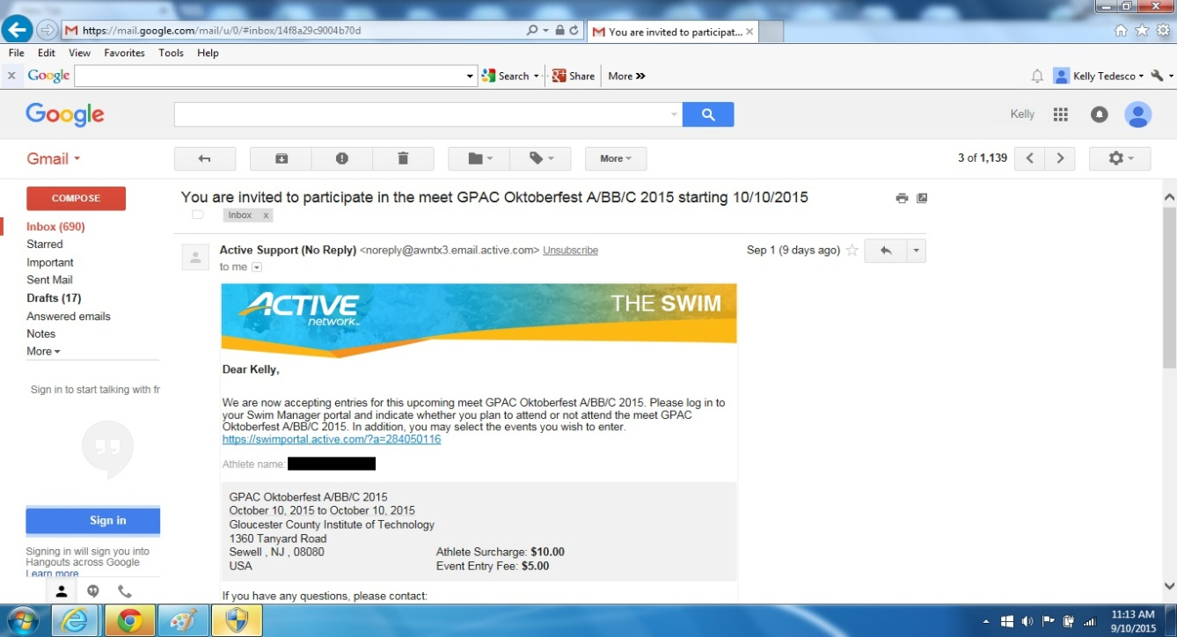
Step 2: Click on the link provided in email. This will bring you to your parent portal. If you delete the email by mistake you can always logon to the parent portal (the link is on the homepage of our website).
Click “View Meets” tab
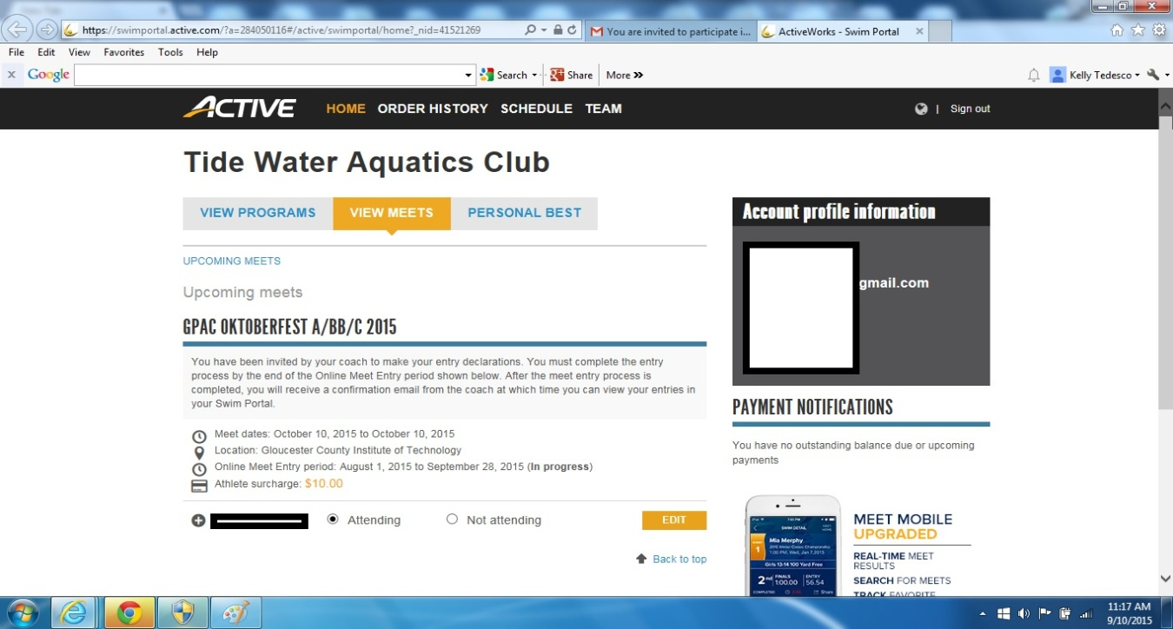
Step 3: Click the radio button “Attending” or “Not Attending”
Step 4: If you choose “Attending” Click “Edit.” The events your swimmer is eligible to swim in will be listed. Notice in this example it is a 2 day meet. You can choose what sessions (days) you want to swim. Check off those events you wish to swim. You can CUSTOMIZE the times if you have it from last season USA Swimming by clicking the pencil icon (see arrow below)
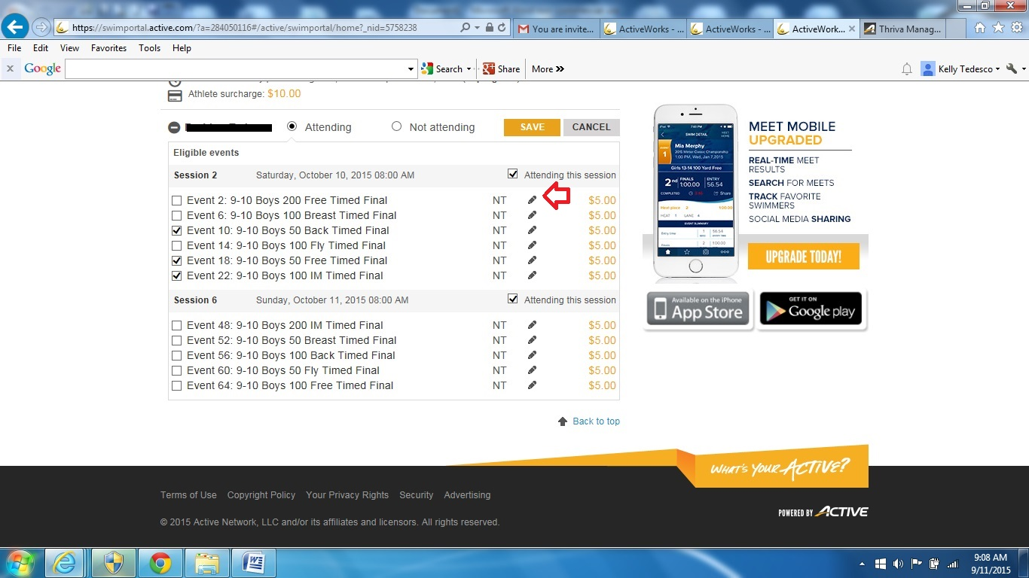
Step 5: Click “Save.” The entries are now complete. You can go back and edit your choices up until the closing date.
The prices per event are listed, as well as any swimmer surcharges. In the example, each event cost is $5 and there is a swimmer surcharge of $10. We chose 3 events for Session 2, the total cost for this swimmer is $25.

Things to know:
- After the meet entry closing date Coach Nancy will review entries, make any necessary changes and approve. You will receive a confirm email and be able to view your final meet entries. Entries will not be changed after this date.
- Your account will be billed and you are responsible for paying the balance due prior to the meet.
- Please understand that when you commit to a meet we pay for those events in advance. If you choose to back out of the meet and not attend after the closing date you are still responsible for those charges.
- Meet payments must be up to date to participate in future meets.
- Results should be populated into the tab “Personal Best” after the host team uploads final results (please note this sometimes takes a couple of weeks)
- This is a new feature for both us & Active Network. We are one of only a few teams that are currently using. Please be patient as we all learn to navigate the system. Any suggestions please let us know, so that we may pass along to Active as they continue to improve on their Swim Manager features.

